SCHOOL

Year 12 Trial WACE Examination, 2013

Question/Answer Booklet

MATHEMATICS 3A/3B
SOLUTIONS

Section One:

Calculator-free

Student Number: In figures

In words

Your name

Time allowed for this section
Reading time before commencing work: five minutes
Working time for this section: fifty minutes

Materials required/recommended for this section

To be provided by the supervisor
This Question/Answer Booklet
Formula Sheet

To be provided by the candidate
Standard items: pens, pencils, pencil sharpener, eraser, correction fluid/tape, ruler, highlighters

Special items: nil

Important note to candidates

No other items may be used in this section of the examination. It is your responsibility to ensure that you do not have any unauthorised notes or other items of a non-personal nature in the examination room. If you have any unauthorised material with you, hand it to the supervisor before reading any further.

Structure of this paper

Section | Number of questions available | Number of questions to be answered | Working time (minutes) | Marks available | Percentage of exam
Section One:  Calculator-free | 7 | 7 | 50 | 50 | 33
Section Two:  Calculator-assumed | 12 | 12 | 100 | 100 | 67
 |  |  | Total | 150 | 100

Instructions to candidates

- The rules for the conduct of Western Australian external examinations are detailed in the Year 12 Information Handbook 2013. Sitting this examination implies that you agree to abide by these rules.

- Write your answers in the spaces provided in this Question/Answer Booklet. Spare pages are included at the end of this booklet. They can be used for planning your responses and/or as additional space if required to continue an answer.
- Planning: If you use the spare pages for planning, indicate this clearly at the top of the page.
- Continuing an answer: If you need to use the space to continue an answer, indicate in the original answer space where the answer is continued, i.e. give the page number. Fill in the number of the question(s) that you are continuing to answer at the top of the page.

- Show all your working clearly. Your working should be in sufficient detail to allow your answers to be checked readily and for marks to be awarded for reasoning. Incorrect answers given without supporting reasoning cannot be allocated any marks. For any question or part question worth more than two marks, valid working or justification is required to receive full marks. If you repeat an answer to any question, ensure that you cancel the answer you do not wish to have marked.

- It is recommended that you do not use pencil, except in diagrams.

Section One: Calculator-free (50 Marks)
This section has seven (7) questions. Answer all questions. Write your answers in the spaces provided.

Working time for this section is 50 minutes.

Question 1 (4 marks)
A student wants to listen to six new songs that they have just bought from an online music store.

One of the songs is called Androids and another is called Blackout.

(a) In how many different orders can these six songs be played given

(i) there are no restrictions? (1 mark)

(ii) Androids must be played first and Blackout must not be played last? (2 marks)

(b) The student plays all six songs in a random order. What is the probability that Androids is played first and Blackout is not played last? (1 mark)
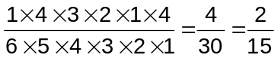

Question 2 (8 marks)
(a) Determine 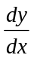 for each of the following.

(i) 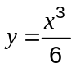 (1 mark)
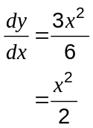

(ii) 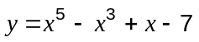 (2 marks)

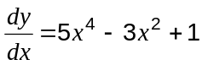

(b) Evaluate 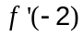 when 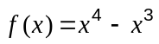. (2 marks)

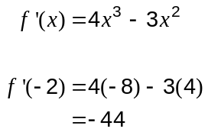

(c) Determine the equation of the tangent to the curve 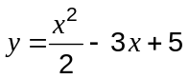 at the point 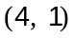.
(3 marks)
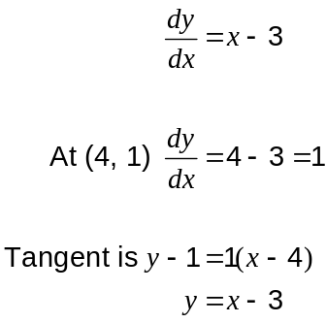

Question 3 (9 marks)
Research into reading and numeracy levels at six schools compared achievement using NAPLAN test results. The graph below shows the average reading and numeracy scores for the six schools and the linear regression model 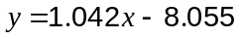 calculated from the data.
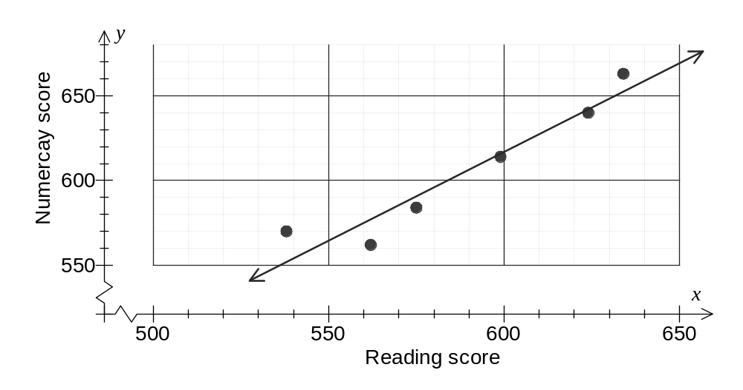
(a) Describe in words the association between the variables (reading score) and (numeracy score) for these six schools. (2 marks)
Strong, positive linear association.

(b) Consider Pearson's correlation coefficient between the variables and .

(i) Place a cross on the scale below for your estimate of . (1 mark)
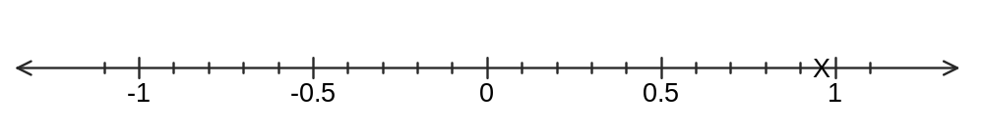
(ii) Would you expect to increase or decrease if the data point (538, 570) was removed from the data set? Justify your answer. (2 marks)

Increase. The remaining five points lie much closer to a straight line.

(c) One of the data points is at (562, 562). Would you predict that a seventh school with a reading score of 562 will also have a numeracy score of 562? Justify your answer.
(2 marks)
No.
The regression line should be used for a prediction rather than a data point and the line shows the prediction will be higher than 562.

(d) Another data points is at (634, 663). Write down a calculation to determine the residual for the linear regression model at this point, but do not evaluate it. (2 marks)
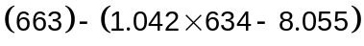

Question 4 (9 marks)
(a) Solve for :

(i) 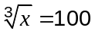 (1 mark)
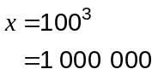

(ii) 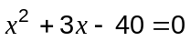 (2 marks)

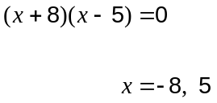

(iii) 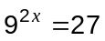 (2 marks)
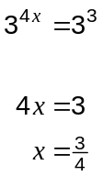

(b) Find the coordinates of the point of intersection of the lines 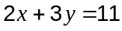 and 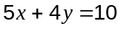.
(4 marks)
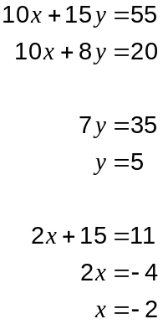

Question 5 (8 marks)
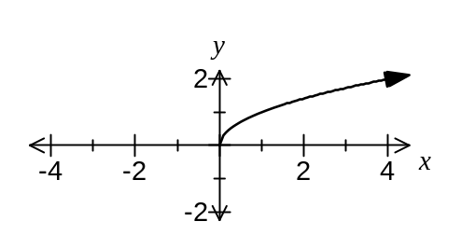(a) The graph of 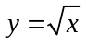 is shown at right.

Describe how to sketch the following graphs using the graph of .

(i) 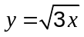 (1 mark)
Dilate horizontally by a scale factor of

(ii) 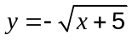 (2 marks)
Reflect in the -axis and translate 5 units to the left.

(b) The shaded area on the graph below is the intersection of the half-planes of two inequalities.
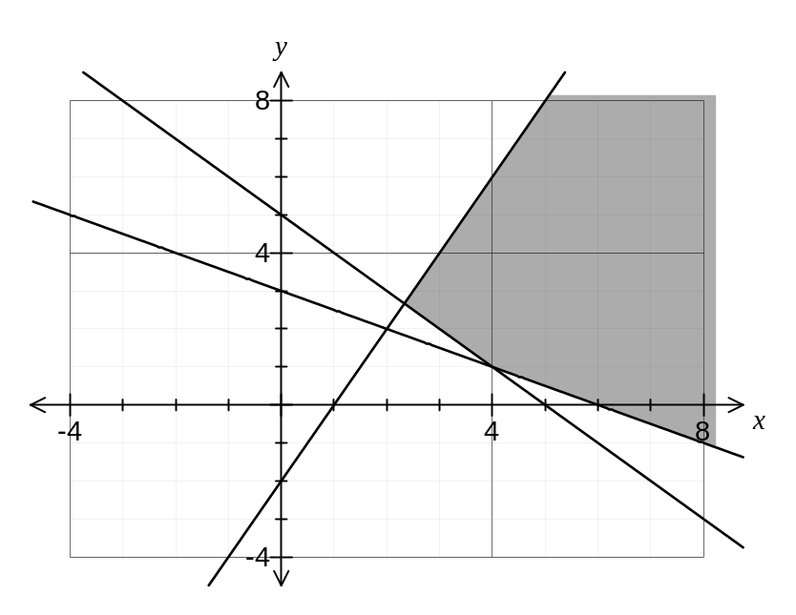
One of the inequalities is 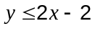.

(i) Write down the second inequality shown on the graph. (2 marks)

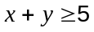

(ii) Add the inequality 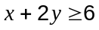 to the graph and clearly shade the resulting region satisfied by all three inequalities. (3 marks)

Question 6 (7 marks)
(a) The area of a plane figure is given by 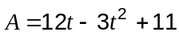, for 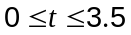.

Use calculus techniques to determine the maximum area of the plane figure. (3 marks)

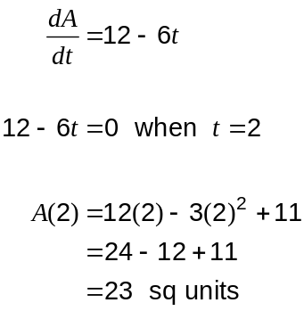

(b) The function 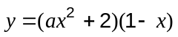 has a minimum turning point when 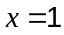.

Determine the value of . (4 marks)
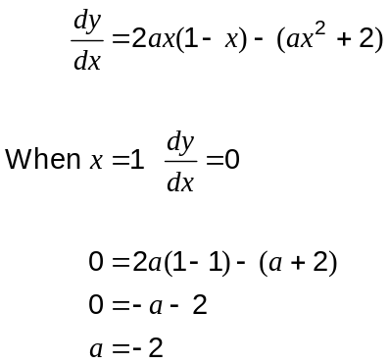
Question 7 (5 marks)
Three integers , and , are derived from two positive whole numbers and , with , as shown:
 | 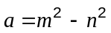 | 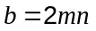 | 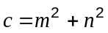

(a) When 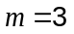 and 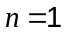, calculate the values of , and . (1 mark)
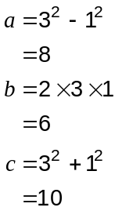

(b) Show that the values of , and calculated in part (a) form a Pythagorean triple of the form 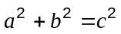. (1 mark)
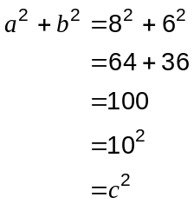

(c) Prove that the values of , and are always of the form . (3 marks)

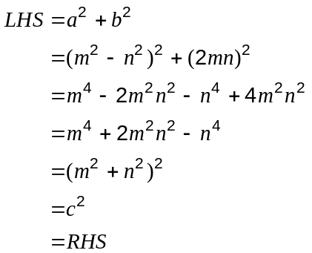

Additional working space

Question number: _________

Additional working space

Question number: _________

This examination paper may be freely copied, or communicated on an intranet, for non-commercial purposes within educational institutes that have purchased the paper from WA Examination Papers provided that WA Examination Papers is acknowledged as the copyright owner. Teachers within purchasing schools may change the paper provided that WA Examination Paper's moral rights are not infringed.

Copying or communication for any other purposes can only be done within the terms of the Copyright Act or with prior written permission of WA Examination papers.

Published by WA Examination Papers
PO Box 445 Claremont WA 6910

